WEEKLY NUTRITION AND CALORIE INTAKE JOURNAL

ASSIGNMENT FOR THE PHYSICAL EDUCATION COURSE


Lecturer :
Dimas Novian Aditia Syahputra, S.Tr.T., M.Tr.T.
Presented by :
Aisyah Currents
25091397108 / 2025I

INFORMATIC MANAGEMENT MAJOR
FACULTY OF VOCATION
UNIVERSITAS NEGERI SURABAYA
YEAR 2026
WEEKLY NUTRITION AND CALORIE INTAKE JOURNAL
Aisyah Currents¹
¹ Undergraduate student D4-Informatics Management, Faculty of Vocational
Universitas Negeri Surabaya
e-mail : ¹currentsaisyah@gmail.com

Abstract
This journal aims to record and analyze daily calorie and nutritional intake over a one-week period during the month of Ramadan. During fasting, eating patterns change to two main meals, namely suhoor (pre-dawn meal) and iftar (meal to break the fast), making it important to ensure that daily energy and nutritional needs are still fulfilled. The method used in this journal is daily documentation of all foods and beverages consumed, followed by calculations of total calorie intake, macronutrients (carbohydrates, proteins, and fats), and micronutrients obtained from each meal. In addition, daily energy requirements are calculated to compare the adequacy of the nutritional intake. The results of this journal provide an overview of nutritional balance while fasting and help increase awareness of maintaining a healthy and balanced diet during Ramadan.
Keywords : nutrition journal, calorie intake, Ramadan fasting, dietary intake

- Introduction

- Daily Energy Requirement Calculation
Before recording the daily food intake, calculate your daily calorie needs using the Dietary Reference Intake (DRI) formula.
Daily Energy Requirement:
1,900 + (10 × Body Weight in kg) + (6.25 × Height in cm) − (5 × Age)
Example:
1,900 + (10 × 43) + (6.25 × 160) − (5 × 19)
= 1,900 + 430 + 1,000 − 95
= 3,235 kcal/day
Daily energy requirement = 3,235 calories.
- Macronutrient Requirement
Based on the daily calorie needs of 3235 kcal, the required macronutrients can be calculated using the recommended percentage ranges. Carbohydrates should make up 45%–65% of the total calories. This means 45% × 3235 = 1456 kcal and 65% × 3235 = 2103 kcal, so the required carbohydrate intake is 1456–2103 kcal per day. Protein should contribute 10%–35% of the total calories, where 10% × 3235 = 324 kcal and 35% × 3235 = 1132 kcal, meaning the required protein intake is 324–1132 kcal per day. Fat should account for 20%–35% of the total calories, where 20% × 3235 = 647 kcal and 35% × 3235 = 1132 kcal, so the required fat intake is 647–1132 kcal per day. These calculations show the recommended range of macronutrient intake based on a daily energy requirement of 3235 calories.
- Micronutrient Requirement
The recommended daily intake of micronutrients is important to support overall health and body functions. An adult is recommended to consume 90 mg of vitamin C per day, which helps support the immune system and aids in the absorption of iron. In addition, the recommended intake of calcium is 1000 mg per day, which is essential for maintaining strong bones and teeth as well as supporting muscle and nerve function. The recommended daily intake of iron is 8 mg, which plays an important role in the production of red blood cells and the transportation of oxygen throughout the body. These micronutrients are necessary to maintain proper body function and support daily physical activities.
- Daily Nutrition Log
Record all food and drinks consumed each day
- Daily Total Intake

- Weekly Reflection

- Conclusion

APPENDIX
Appendix A. Daily Nutrition Log Table
Day | Meal | Picture | Macronutrients | Micronutriens | Calories
Tuesday  10 March 2026 | Suhoor |  | Carbohydrates | Vitamin C
 |  |  | Protein | Calcium
 |  |  | Fat | Iron
 | Iftar |  | Carbohydrates | Vitamin C
 |  |  | Protein | Calcium
 |  |  | Fat | Iron
Wednesday | Suhoor |  | Carbohydrates | Vitamin C
 |  |  | Protein | Calcium
 |  |  | Fat | Iron
 | Iftar |  | Carbohydrates | Vitamin C
 |  |  | Protein | Calcium
 |  |  | Fat | Iron
Thrusday | Suhoor |  | Carbohydrates | Vitamin C
 |  |  | Protein | Calcium
 |  |  | Fat | Iron
 | Iftar |  | Carbohydrates | Vitamin C
 |  |  | Protein | Calcium
 |  |  | Fat | Iron
Friday | Suhoor |  | Carbohydrates | Vitamin C
 |  |  | Protein | Calcium
 |  |  | Fat | Iron
 | Iftar | 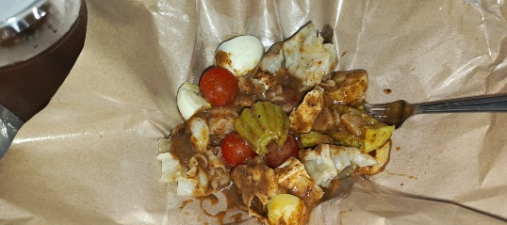 | Carbohydrates | Vitamin C
 |  |  | Protein | Calcium
 |  |  | Fat | Iron
Saturday | Suhoor |  | Carbohydrates | Vitamin C
 |  |  | Protein | Calcium
 |  |  | Fat | Iron
 | Iftar |  | Carbohydrates | Vitamin C
 |  |  | Protein | Calcium
 |  |  | Fat | Iron
Sunday | Suhoor | 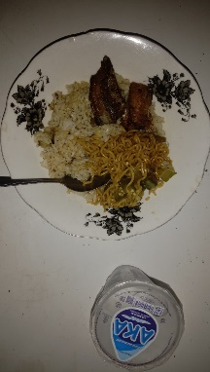 | Carbohydrates | Vitamin C
 |  |  | Protein | Calcium
 |  |  | Fat | Iron
 | Iftar | 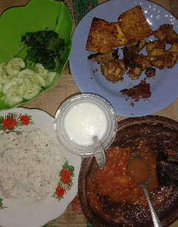 | Carbohydrates | Vitamin C
 |  |  | Protein | Calcium
 |  |  | Fat | Iron
Monday | Suhoor | 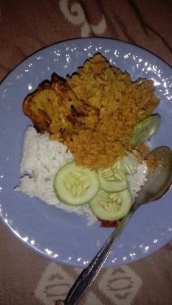 | Carbohydrates | Vitamin C
 |  |  | Protein | Calcium
 |  |  | Fat | Iron
 | Iftar | 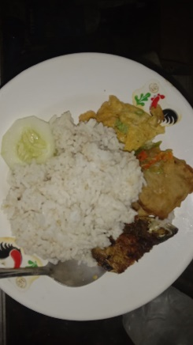 | Carbohydrates | Vitamin C
 |  |  | Protein | Calcium
 |  |  | Fat | Iron

Appendix B. Daily Total Intake Table

